Thor

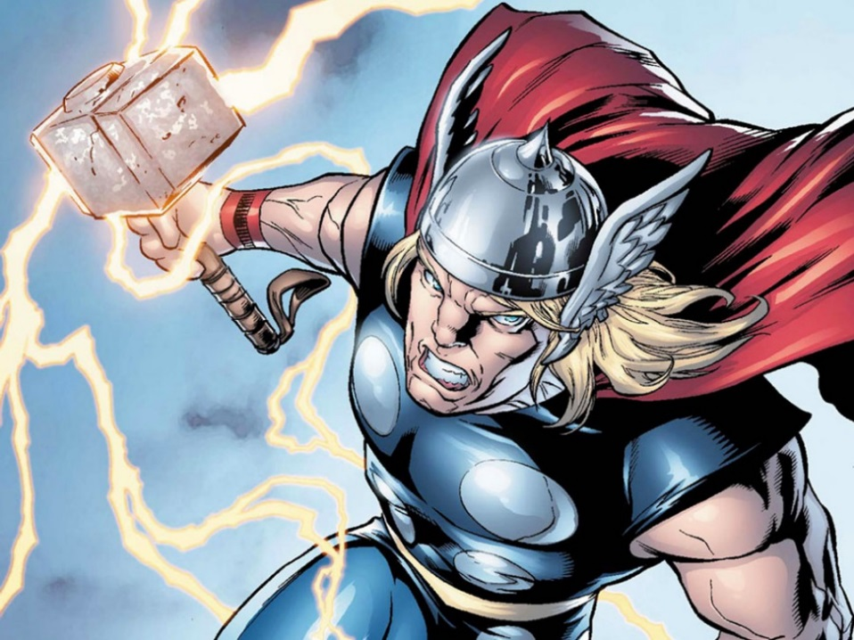
Real Name: Thor Odinson

Occupation: Asgardian God of Thunder; protector of the human race

Height: 6’ 6”

Weight: 640 lbs.

Powers and Abilities

Asgardian/Elder God Hybrid Physiology: Biologically half-Asgardian on his father's side and half-Elder God on his mother's side; Thor possesses a number of superhuman attributes common among the Asgardian and other gods. However, due to his unique birth, some are considerably more developed than those of the vast majority of his race. Thor's skin, muscle, and bone tissues have several times the density of the same tissues in the body of a human being, contributing to his superhuman weight. He is invulnerable to powerful energy blasts, weighted impacts, falls from great heights, explosions and various other opposing forces. Even without his godly power Thor is still physically the strongest and most durable of all the Asgardians.

Superhuman Strength: In addition to being the God of Thunder, Thor is also the Asgardian God of Strength, as such he is physically the strongest of the Asgardian gods. His feats include destroying an arch weighing over a million tons, crumbling Uru into dust, snapping and adamantium alloy cables by simply flexing. Thor has proven capable of several acts of vast physical strength, including stalemating Hurcles and even the Hulk in battle for an hour.

Superhuman Durability: Being a god whose heritage is both half-Asgardian and half-Elder God affords, Thor is immune to such human ailments as diseases, toxins, poisons, corrosives, fire, electrocution, asphyxiation, and lead and radiation poisoning. Thor can drink mead all day long and not get drunk. Thor has flown through the heart of stars. Thor has survived a glancing hit by a Doomsday Bomb that was capable of ravaging an entire planet, and soon after that explosion, he fell from space (leaving a crater miles wide) to a planet called Pangoria. Thor is extremely difficult to kill as his life force is considerably augmented by his godlike heritage, and Mjolnir.

Superhuman Speed: Thor can move at extreme speeds. Thor can fly to the sun in a matter of minutes. Thor once stated that he was as fast as the lightning he commands.

Superhuman Stamina: Thor's advanced musculature is considerably more efficient than that of a human and most other Asgardians. His virtually inexhaustible stamina enables him to hold his breath for an undefined period of time, and exert himself at peak capacity for months without tiring at all. Using the Belt of Strength also doubles his stamina. While in the state of Warrior's Madness, Thor's stamina also increased tenfold.

Superhuman Senses: Thor's superhuman senses allow him to see objects as far out as the edge of the solar system, allow him to track objects traveling faster than light, and hear cries from the other side of the planet.

Healing Factor: Thor is not invulnerable to all harm and it is possible to injure him. But due to Thor’s unique physiology, he is able to heal from most injuries much faster than a human being could. However, Thor cannot regenerate lost limbs.

Super Breath: Thor can use his breath to create hurricane force winds.

Flight: Thor has shown the ability to fly and levitate without his hammer.

Self Sustenance: He is capable of surviving in the vacuum of space unaided and does not need air, food, water, or sleep.
Thor the God of Thunder

Lightning: Thor is capable of discharging lightning bolts from his hands. He also summoned a lightning bolt from the sky without Mjolnir to revive himself from near death.

Indomitable Will: Thor has shown to have a powerful force of will, so much so that he has defied the will of his father, Odin, who is his king and is bound to serve him. He does not back down from any foe, does not give into a figh,t and is willing to lay down his own life in defense of others.

Expert Combatant: A little known fact about Thor is that not only is he known throughout history as the Norse God of thunder and strength, but also of war. Since birth, he has been groomed to be Asgard's finest warrior. He has shown proficiency in hand-to-hand combat, aerial combat, swordsmanship, mace wielding, hammer throwing, and wrestling. Being a God of War, he has mastered various fighting styles from both Asgard and Earth.

Mind Resistance: Thor has the ability to resist the mental influence of powerful beings.

Skilled Tactician: For millenia, he has lead Asgard into battle against overwhelming forces with great leadership and employing strategies and tactics.

Weakness

Warriors' Madness: Warrior's Madness is the most forbidden malady in Asgard by law of Odin. Any who fall under it must pay the penalty, only the most bitter sacrifice can atone for it. Despite this allowing Thor to increase his strength and stamina tenfold, this threatens Thor's sanity. Symptoms include massive headaches, mentally erratic, savage, animalistic, uncontrollable behavior, and unreasoning.

Paraphernalia

Megingjord: A magical belt worn by the Thunder God that would double his natural strength and stamina. The belt is fueled by the Odin Force and can also increase the might of Mjolnir. When Odin fed a large amount of Odin Force into it, the belt increased Thor's strength so much that he was able to knockout a powered-up Thanos clone.

The Odinsword Ragnarok: His father's sword and he used it to slay his uncle Cul the Serpent.

The Asgardian Warhammer Mjolnir: Thor wields Mjolnir, a magical hammer forged from Uru metal, whose chief properties are durability, the ability to maintain enchantment, and absorb energies. Mjolnir resembles more of a short handle mallet than a traditional warhammer. Mjolnir itself is already extremely durable, and combined with the various enchantments placed upon it by Odin, is even harder. It has survived heat as extreme as the heart of the Sun, and blasts powerful enough to destroy planets. Thor often uses the hammer as a physical weapon. It has been described as impacting with sufficient force to destroy mountains.

Powers of Mjolnir

Worthiness Enchantment: This enchantment surrounding Mjolnir prevents it from being wielded by anyone save those who have been found worthy. Thus far, this includes Thor, the Red Norvell, Beta Ray Bill, and Captain America. To anyone else, Mjolnir cannot be lifted from the ground nor wrested from Thor’s grip. Those who are deemed worthy are able to wield Thor's powers.

Mystical Link: Mjolnir obeys Thor’s commands as though it were alive, and if Thor’s will is strong enough, the hammer can pass through nearly any barrier to reach him should he so chooses; Mjolnir will even carve its way through the very center of entire planets to get back to Thor.

Weather Control: Wielding Mjolnir grants Thor the ability to control the base elements of a storm, i.e. rain, wind, thunder, ice, snow and more. He can create giant raging storms complete with thunder, hurricane-force winds, tornadoes, blizzards, tidal waves, exploding volcanoes, earthquakes and torrential rains across entire planets at a moment's notice.

Flight: Thor is capable of hurling Mjolnir with great force and, by holding onto the leather thong, is capable of flying through the air at tremendous speeds.

Energy Projection: With Mjolnir, Thor can project powerful mystical blasts of energy. He can even channel energies for stronger energy attacks.

God Blast: Thor is capable of channeling different amounts of his godly energies in combination with the mystical properties of Mjolnir can be channeled through his hammer for a single massive blast known as the God Blast which is able to kill even immortals.

source: http://marvel.wikia.com/Thor_(Thor_Odinson)

