Iron Man
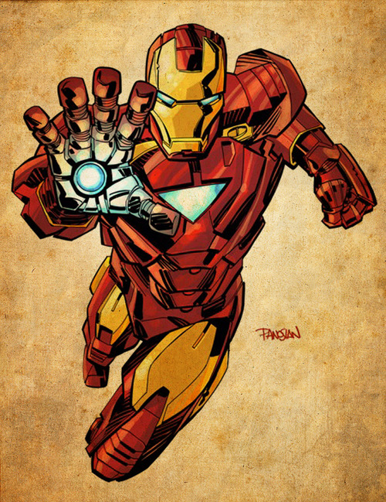
Real Name: Anthony Edward “Tony” Stark

Occupation: Adventurer, president emeritus of Stark Industries, founder of Maria Stark Foundation; formerly director of S.H.I.E.L.D., CEO of Stark Industries, Stark Solutions, Stark Enterprises, Circuits Maximus & Stark International, US Secretary of Defense, computer technician

Height: 6’11”

Weight: 225 lbs.; 425 lbs. in armor

Education: Ph.D.s in physics and electrical engineering

Powers: Thanks to the Repulsor Tech node implanted in his chest, which is linked to his brain, Tony is able to interact with different types of energies and forces a normal human cannot. The R.T. node acts like a new sense for its user. The reactor's excessive generation of energy provides Stark with an increased amount of intelligence and gave him superhuman-level multitasking and learning capabilities.

Iron Man Armor: Iron Man's primary powers mostly come from his armored suit.

Support Powers

Superhuman Strength: He is capable of lifting up to 100 tons when wearing his armor and can achieve higher levels of strength when powered by a sufficiently more powerful source.

Superhuman Speed: Even when not traveling for extended distances, the armor enables the wearer to move and react at very high speeds.

Flight: The armor can typically reach speeds in excess of Mach 10, however Iron Man has been recently depicted as able to reach orbital escape velocities (5 miles per second) and up to speeds that can outrun black holes. Use of the jet boots provide enough power to lift a load of about 500 tons.

Power Cells: Most of his armors are powered by a combination of solar converters, electrical batteries and an on-board generator that uses beta particle absorption as a fuel source. Current models after Iron Man Armor Model 38 use a Repulsor Tech generator located in Stark's chest to be powered.

Energy Conversion Power Recharge: The armor is also able to absorb and convert nearby or far away energy sources, such as heat, solar, electrical, magnetic, geo-thermal or kinetic energy or energy from the planet itself into electricity, or even drain energy directly into the batteries for recharge.

Self-Contained Life-Support System & Environmental Protection: The armor can be completely sealed for operations in vacuum or underwater, providing its own life support, and is shielded against radiation, biological, chemical, corrosive, kinetic, and electrical attacks as well.

Magnetism: The armor can generate magnetic fields to pull or push metal objects at will.

Anti-Magnetism: The armor Tony has to negate the effects of magnetism on it. Tony skill is used often to be immune to the powers of Magneto. This skill can be triggered when the armor picks next wave magnetism.

Onboard Computer: The armor has an internal onboard computer operating system that aids Stark in providing strategies, background information on opponents, surroundings, the status of the suit, and prevents a lock on from targeting systems.

Override: When required, armor systems including strength amplification, durability amplification, and repulsor intensity can be greatly increased, by bypassing safety circuits and limiters. However, there is a chance that this can result in a complete system failure of the armor. An example of this mode is when Iron Man easily lifted a 16,000 ton Nuclear Reactor, and flew into the sky and threw it into the sea. It seems that he utilized this resource on the Hulk once, as the armor ends up completely inert. The range of the Override can be controlled as only reaching his very limit and staying at it for a long time will cause a system failure. This range goes from a safe 800% to 3200%, up to a very dangerous 5000%.

Defensive Powers

Enhanced Durability: His armor is very durable, capable of withstanding tremendous amounts of punishment. It can withstand high caliber bullets with ease. He can also withstand rockets, missiles, torpedoes, high powered lasers, and such, taking little to no damage. Future armors were fully resistant against electricity, fire, heavy impacts, energy blasts, take zero Kelvin and up to the Suns temperatures, even some of Thor's attacks. The suit can withstand almost unlimited kinetic and thermal impact, as well as most forms of radiation thanks to its refractory coating. The armor can survive anything short of a nuclear explosion at ground zero. The suit automatically protects its wearer when he enters an intrinsically hostile environment, such as outer space or deep sea. The armor even has specialized circuitry that guards against telepathic attacks. Tony is very confident in his suit's defensive abilities, when he was caught in a nuclear explosion, he was only thinking about women and completely forgot about what was happening around him.

Energy Shield: Energy shielding that can protect the user from harm. It is also capable of reflecting attacks and staying mobile. At 2% power, the shield is strong enough to withstand a nuclear explosion.

Offensive Powers

Repulsor Rays: The armor's primary energy weapon. A particle beam weapon, standard equipment in the palm gauntlets; can repel physical and energy-based attacks, traveling as a single stream or as a wide-field dispersal. It's damage potential is extremely lethal, from being able to go through 2 inches of steel like paper to blasting a hole through a mountain. They can be powered up to make a larger beam or a Full Form repulsor Ray, which does 360 degrees of attacks. The power of the repulsor Beams can range from the basic ones such as the one from the Mark 3, which fires 2 gigawatt beams, to the beams on a much further model of the suit such as the Model 27 which fires beams in the high petawatt region, but those require a little assistance from outside. The latest model of repulsor technology is that of Mark IVa, used for the first time in the Iron Man Armor Model 42, featuring a red color.

Unibeam: A powerful searchlight, capable of projecting beams in virtually every light spectrum. Also used as a powerful weapon that can destroy anything in its path. It fires a boosted form of the Monobeam with some energy backing it up.

Smart Missiles: The Smart Missile is one that can target the weak points of a structure, object, or foe to inflict maximum damage with a minimal payload.

Hyper-velocity Impact: The program Hyper-velocity allows Tony to think and move at a much faster time frame than everyone else, allowing for quicker attacks. Also, it could create an electrical bubble if Tony is going fast enough.

Abilities

Super-Genius class Intelligence: Quite apart from the powers granted him by the suit, Tony Stark is far more than a mechanical engineering prodigy who graduated from the Massachusetts Institute of Technology with honors at the age of 17.

With an intelligence classed as super-genius, he easily is one of the smartest people on Earth. Furthermore, this extends to his remarkable ingenuity dealing with difficult situations such as difficult foes and deathtraps where he is capable of using his available tools, like his suit, in unorthodox and effective ways, as an example: when he built the first Iron Man Armor in captivity. He has also been able to hack even technology from the aliens Kree, a race centuries more advanced than humans.

More recently, Stark's intelligence grew to super-human levels with more energy being emanated to his brain thanks to the R.T. node in his chest, levels which even left Mr. Fantastic amazed.

Expert Engineer: He is an excellent engineer and mechanic capable of fixing almost, if not all, any machinery.

Expert Tactician: He is a brilliant tactician capable of quickly formulating battle strategies and new plans if the situation changes, like being able to elaborate different complex plans in order to defeat different enemies in difficult situations, and be victorious. Even going as far as to simultaneously put Reed Richards in check on five different boards playing chess, a game he didn't learn until later in his life, leaving Richards totally astonished.

Skilled Combatant: Stark was trained in unarmed combat by Captain America, Black Widow, Black Panther and Shang-Chi and has become quite physically formidable on his own when the situation demands it. He has managed to fight trained Hammer Industries guards, defeat five trained Skrull soldiers in single-handed combat and numerous Voldi gladiators.

Indomitable Will: As evidenced by his two serious bouts with alcoholism and subsequent recovery, Stark is possessed of tremendous strength of will, never giving up and often emerging from defeat even stronger. It is arguable that the true "Iron Man" is not the armor, but Stark himself.

source: http://marvel.wikia.com/Iron_Man_(Anthony_%22Tony%22_Stark)

