Hulk
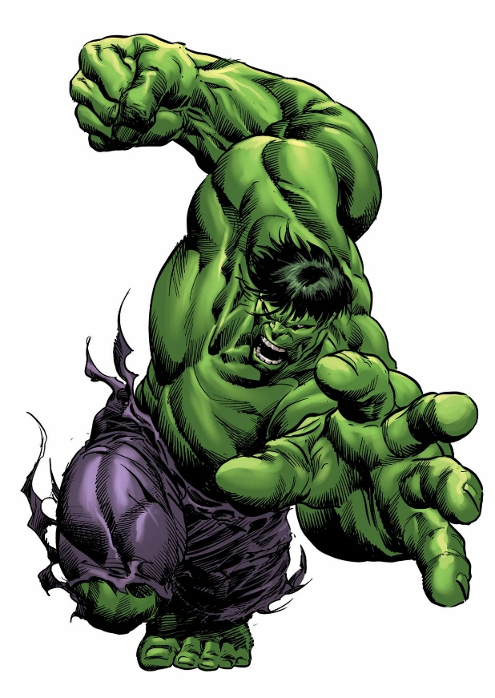
Real Name: Robert Bruce Banner
Occupation: nuclear physicist
Height: 5' 9" (as Banner); 7'- 8' (as Hulk)
Weight: 128 lbs (as Banner); 1,040 lbs - 1,400 lbs (as Hulk)
Powers and Abilities
Transformation: The process by which Banner usually transforms into the Hulk is presumably the result of the chemical catalyst, adrenaline. As in normal human beings, Banner's adrenal medulla secretes large amounts of adrenaline in time of fear, rage, or stress. Whereas the secretion heightens normal physical abilities in normal human beings, in Banner's case it triggers the complex chemical-extra-physical process that transforms him into the Hulk. As the Hulk's transformation is mostly a stress reaction, it is virtually impossible to attack, wound or sedate him in his human form without Hulk erupting almost instantaneously in self-defense.
Superhuman Strength: The Hulk possesses the capacity for virtually limitless physical strength. Among the Incredible Hulk's most amazing feats of strength are: Supporting and rising up despite being weighed down with a force that was claimed to be equal to the weight of a star; and breaking through heavy duty blastdoors capable of withstanding a nuclear strike with a punch.
Superhuman Leaping: The Hulk is able to use his highly developed leg muscles to leap great distances. As the Hulk becomes enraged, his strength increases considerably, which means he can jump farther than usual. The Hulk has transposed 1,000 miles with a single leap, and he jumped on top of the Mount Olympus from ground level, in one single leap. On more than one occasion, the Hulk has nearly jumped into the Earth's orbit.
Superhuman Stamina: The Hulk's body counteracts fatigue poisons that build up in his muscles during physical activity. In an enraged state, the Hulk is capable of exerting himself at peak physical capacity for several days before fatigue begins to affect him. However, much like his vast physical strength, the Hulk's stamina does increase as he becomes angrier. In an enraged state, the Hulk was able to efficaciously stalemate the warrior's madness Thor (a state which temporarily enhances Thor's strength and stamina to 10 times that of his normal state in exchange for adversely affecting his intelligence). The Hulk's stamina has even been described as "almost unlimited."
Superhuman Durability: In addition to great strength, the Hulk's body possesses a high degree of resistance to physical injury. The Hulk has survived tremendous amount of punishment throughout his career. The Hulk's skin is impervious to conventional blades, adamantium and vibranium being strictly the few known metals that can effectively pierce and penetrate his skin. The Hulk is capable to withstand high caliber bullets, high-powered energy blasts, pressures extremes, falls from orbital heights, maximized heat without blistering, maximized cold without freezing, and also powerful impacts. The Hulk has withstood several times the impact of ground zero nuclear explosions. The Hulk's durability, much like his strength, is fueled by rushes of adrenaline while angry.
Regenerative Healing Factor: Despite the Hulk's high resistance to physical harm, it is possible to cause the Hulk injury. However, the Hulk is capable of regenerating damaged or destroyed areas of his body with much greater speed and efficiency than an ordinary human. In fact the Hulk was able to systematically regenerate his internal organs and tissues in an alternate reality. The Hulk also demonstrated his exceptional healing capacity when, during a battle with Vector; all of his skin and most of his muscle mass were extracted from his body. Hulk regained his mass and healed within only seconds. Additionally, the Hulk heals faster and more extensively the madder he gets. Combined with the Hulk's superhuman durability, this makes him extremely difficult to defeat or incapacitate.
Superhuman Speed: Regardless of his size, Hulk's superhumanly strong legs allow him to run at speeds that are well beyond the natural physical limits of even the finest human athlete. The Hulk has once spun around like a tornado to get Mr. Fantastic off him. Hulk has been fast enough to capture mortar shells and missiles shot at him. The Hulk has also eventually been recognized to be extremely agile proportionally to his size. [17][108][45][216][296][235] His reflexes have even been described as "lightning-fast reflexes."
Reactive Adaptation: There have been several events in the past where Hulk has not only faced extended periods of time in oxygen-less outer space without suffocating, but he has also repeatedly spoken in these inhospitable habitats.
Weaknesses
Radiation Bombardment: Hulk was highly vulnerable to being weakened by radiation bombardment in the past, a weakness which was quite exploited by his enemy X-Ray, who was able to weaken Hulk and even transform him back into Banner. However, Hulk has acquired a rate of immunity to this weakness.
Adamantium and Vibranium Blades: They have been shown capable of piercing Hulk's skin; Wolverine, X-23, and Black Panther's claws can pierce it. However, as the Hulk's rage increases they become progressively more ineffective, reaching the stage they are completely inefficient to harm him.
Adrenaline Suppression: Adrenaline inhibitors can be administered via syrings of adamantium and vibranium, objectifying to revert the transformation into the Hulk. Amplified quantities can accomplish this purpose successfully.
Toxic Substances: Once, Carmilla Black injected into his body a toxin especially designed to counteract the efficiency of Hulk's healing factor. However, if the Hulk gets angry enough he can nullify this effect, as he demonstrated later.
Rage Nullification: The Hulk's rage also can be neutralized; certain individuals can calm the Hulk down. Elizabeth Ross (Earth-616) and the Sentry successfully calmed him down in several instances. Telepaths with vast empathy potential can theoretically emulate this effect.
Strength Increasing Factor: The Hulk normally doesn't achieve full strength in the first moments after his transformation. Unless there is a substantial and significant event that breaks Banner's restraints and triggers far superior amounts of adrenaline in his circulatory system.
Magic: Since the Hulk is empowered by dark magic, it is not properly a weakness. However, depending upon his emotional state, his incarnation, and the power magnitude of the magic manipulator, this could be a potential threat. Also, Hulk has been shown to be injured more easily by enchanted weapons than regular weapons.
Extreme Conditions: Finally, he can be hurt or even killed by cosmic entities or individuals with similar extraordinary level of power, and under some conditions be psychically manipulated by exceptionally powerful telepaths.
source: http://marvel.wikia.com/Hulk_(Robert_Bruce_Banner)#cite_ref-329

