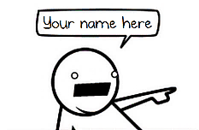
Comic Self Evaluation d d

Ideas and Creativity
A B C D
My comic has nothing interesting or unique to say.

My comic is original and insightful. After people read it, they say, “Ha! That was funny/clever/ thoughtful/profound!” My comic answers the “so what?” question that plagues artists and writers.

Organization and Transitions
A B C D
My comic is confusing and disorienting. While someone is reading it, he/she has to stop several times, scratch his/her head, and ask, “So, what happened here? How did you go from here to here? I’m really confused.”

My comic has a clear beginning, middle, and end. The ending of my comic leaves the reader with a satisfying sense of closure. Each panel logically flows to the next; moments are chosen carefully to guide the reader through the plot. When people read it, they never have to go back and ask, “So, what happened here? I’m confused.”

Images and Word Choice
A B C D
My comic’s images and words work together to seamlessly communicate an idea with clarity. I chose each image and word for a specific purpose, knowing it would have an impact on my readers.

The images and words in my panels leave my readers confused.

Presentation and Quality
A B C D
While I may have only drawn simple figures, they are darn good simple figures. My drawings are clean and neat, and my words are easy to read. It looks like my comic is ready for prom.

My comic is haphazard, sloppy, and messy. It looks like my comic woke up with a hangover.

Effort
A B C D
Dude, I spent a total of three minutes during lunch on this assignment, and I wrote it on my ketchup-stained napkin.

I probably spent too much time on this because it was a labor of love or because I’m a self-loathing perfectionist who expects nothing less than flawlessness. I did at least one rough sketch; then I penciled and inked my final comic.

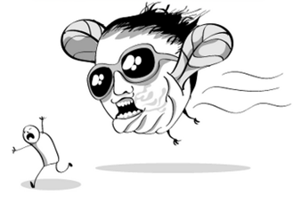

Reflection Questions:
Write a one+ page reflection on one
or more of the following questions.
- Why did you chose the topic you did?
- Chose a panel or two and discuss why you chose the particular images, words, placement, etc. that you did? What effect did you hope to have on your readers? Did those choices work? Why or why not?
- What was your biggest struggle? How did you overcome this challenge?
- What did you like or not like about this comic unit?
- What changes can Mr. Bockholt make for the next time he teaches this unit?
*All images on this handout are from The Oatmeal.*

