Captain America
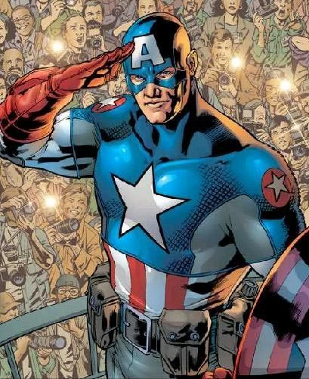
Real Name: Steven "Steve" Rogers
Height: 6'2"
Weight: 220 lbs
Personality
Captain America is traditionally seen as the greatest hero of the Marvel Universe. He is a righteous and brave man who always wants to see the good in people. From his origins as a superhero, Cap has always devoted himself to the protection of the weak and the defense of freedom and justice. In spite of his virtues, however, Cap is plagued by his status as man out of time. Remembering his days as a soldier in World War II, Cap is worried that his idealism might be considered outdated in the modern world. Furthermore, seeing how idealized his legacy has become throughout the years, Cap sometimes believes that he might be not be able to fulfill the image the world has of him. Regardless, Cap is still seen as the pinnacle of heroism and an example for everyone to follow.
Abilities
Master Martial Artist: Rogers is an expert in hand-to-hand combat being very skilled in multiple martial arts through his training in military combatives and instruction under various private instructors. He mainly utilizes American Boxing, Judo, Aikido, and Jujutsu. He combines these various fighting styles with his gymnastics ability, creating a style that suits his strengths and enables him to use his knowledge to the best of his ability.
Master Shieldmanship: His years of training and experience with his unique shield, as well as its physical properties, allow him to accomplish amazing feats with the item. Aside from bashing foes and blocking incoming attacks, he is able to throw it with nearly perfect aim. Rogers can hit multiple targets with the same throw by means of ricochet, and could even achieve a boomerang-like return effect, allowing him to strike enemies from behind or retrieve the shield without objects to ricochet from.
Master Tactician and Strategist: Rogers is an accomplished strategist. He had been widely considered one of, if not the greatest, tacticians on the planet, both on and off the battlefield. He is able to formulate battle strategies and his brilliant tactical sense allows him to alter any strategy to fit the changing need of the situation.
Advanced Military Operator: He is well-versed in all Armed force disciplines including intelligence gathering, escape arts, assassination, demolition, survival tactics, hunting, swimming, mountaineering, march/drill skills, map making and reading, decoding cipher and other secret code messages, reading and making wood craft signs and other secret code languages, disguising, interrogation, computers, explosives, communication systems, vehicles and electronic appliances used in armed forces.
Indomitable Will: Rogers is a very strong-willed person. He is able to overcome most forms of temptation and resist the effects of extreme pain, drugs and toxins to a great extent. Rogers accepts his own mortality, and refuses to rob any sentient creature of its freedom. Rogers is also capable of resisting all forms of mind control; only the strongest willed individuals have a chance of enslaving him.
Expert Marksman: He can throw most projectile weaponry with great aim and is well-versed in the use of firearms.
Weapons Proficiency: While he prefers his shield, he is proficient in wielding bladed weapons and firearms.
Strength level
He has been known to overhead press 800 lbs, but had also bench-pressed 1,200 lbs and curled 500 lbs. He is cited as having the strength of 10 men and had himself once stated that he has the strength of half a platoon of fighting men.
Equipment
Uniform: As Captain America he wears a water and fire retardant costume, which is made of Kevlar, nomex and light weight titanium. The costume also offers a medium level of resistance to electric shocks and force impacts i.e., falls from 30 meters height and the suit cannot be pierced by normal conventional sharp edged materials like sharp wood, glass, iron, copper and aluminum. The suit also gives some resistance to high temperatures. He carries a voice-operated, wireless communicator in his left ear, which has its frequencies blocked making it highly difficult to trace its call.
Shield: Captain America's only weapon is his shield, a concave disk 2.5 feet in diameter, weighing 12 pounds. It is made of a unique Vibranium-steel alloy that has never been duplicated. It can withstand attacks from the most powerful Marvel characters including Thor with Mjolnir and Hulk's strength without any visible damage. It is able to absorb all kinetic energy and transfers very little energy from each impact, meaning Captain America does not feel recoil or impact from blocking attacks. It also means the shield can bounce off of surfaces, ricocheting multiple times with little loss in velocity. The sharp edge of the shield also allows him to cut his opponents, though he normally prefers to bludgeon them instead.
source: http://marvel.wikia.com/Captain_America_(Steven_Rogers)

